**Student Questions**

Learn about the internals of a standard PC case by examining physical samples and selecting and labeling images found on-line. Gain deeper knowledge by researching and reporting on specific components.

PC Tower Case

1. Find one (or more) images that clearly show the internals of a PC Tower Case.   
   (i.e. Google images using keywords “PC Case Internals”)

1. Clearly label the following components (using arrows) on your image of the PC case internals:

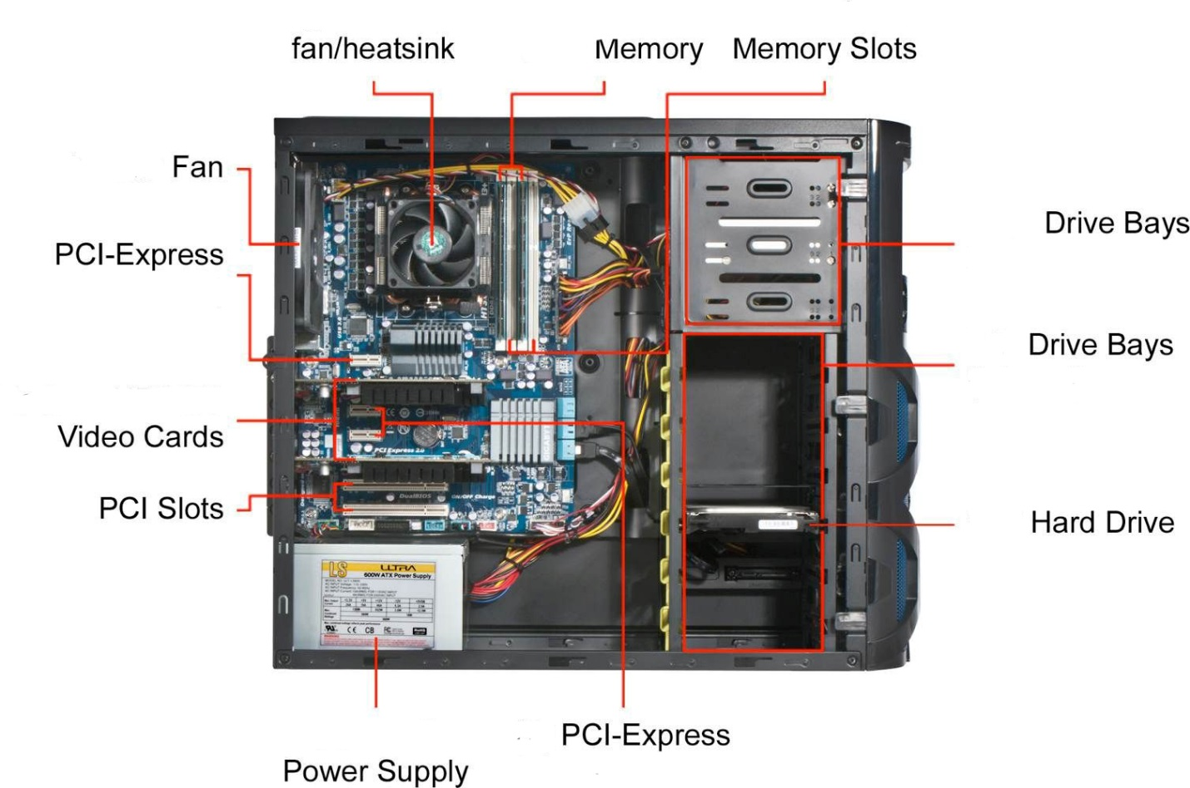

1. Research more in-depth about “Hard Disk Drives”. Make notes on the following:
   1. What different versions are currently available (speed and capacity)
      1. Seagate BarraCuda 1TB 6.0Gb/s
   2. How the capacity of the component has changed since the 1980’s
      1. Back in 1980’s the maximum space was 2.5 GB and it weighed more that 500 pounds and it was for $40,000

PC Motherboard

1. Find one (or more) images that clearly show the layout of a PC Motherboard.   
   (i.e. Google images using keywords “PC Motherboard”)
2. Clearly label the following components (using arrows) on your image of the PC motherboard:

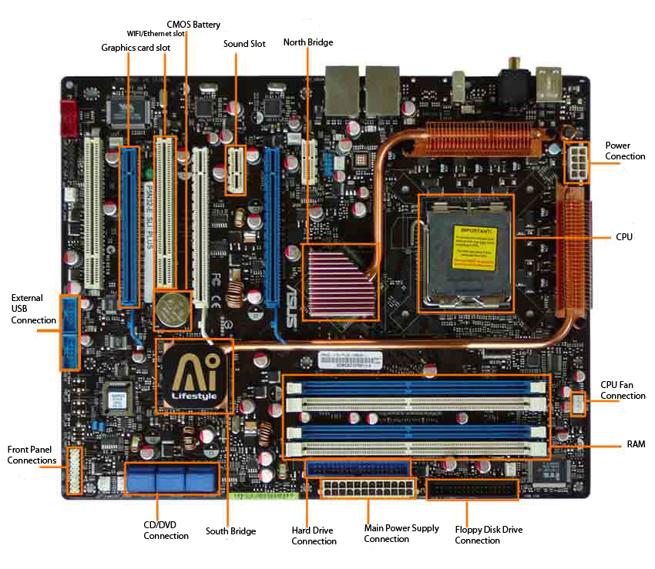

1. Research more in-depth about “CPU Processor Chip”. Make notes on the following:
2. What different versions are currently available (speed and capacity)
   1. AMD RYZEN 7 3700X 8-Core 3.6 GHz clock speed
3. How the speed of the component has changed since the 1980’s
   1. The Intel 8086 was the first backward compatible CPU and only had 4 – 12 MHz clock speed

Peripheral Devices

1. Find one (or more) images that clearly show the layout of the back of a typical PC tower case.   
   (i.e. Google images using keywords “Back Of PC Tower”)
2. Clearly label the following components (using arrows) on your image of the back of a typical PC tower case:

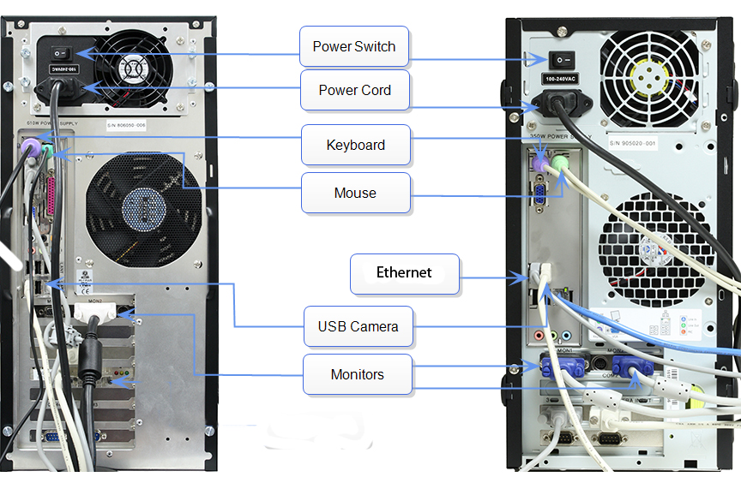

1. Research more in-depth about “External Portable Storage”. Make notes on the following:
2. Floppy Disks
   1. Floppy disks Are cd’s that hold memory in them
3. CD-ROM / DVD / Recordable CD/DVD
   1. A DVD is a floppy disk that is mainly used to hold media files mainly films
4. USB Memory Drives
   1. Are portable small HDD or more closer too SDD since they are faster
5. Compact Flash Memory
   1. Flash memory is fast memory
6. Cloud Based Storage
   1. Cloud based memory is held in servers accessible from anywhere on any device.

**Presentation Outline**

Explore the development and features of a specific PC hardware component through deeper research and investigation. Work in partners to create a short presentation. Deliver the presentation to the class.

Each group will research a unique PC hardware component. Your specific topic will be assigned from the list provided below.

**Presentation Structure**

1. Explain what the PC component does and how it fits together with other components to make up a fully functioning PC.
2. Explain how the PC component works. Provide a diagram (image) showing the main parts of the component.
3. Research the current state of the art of the component in terms speed, capacity (size), and other related factors.
4. Research on-line suppliers that sell the PC Component. List the specifications for the available products and the cost (price).
5. Research how the PC component has changed and evolved since the early days of PCs in the 1980’s. Cover each of the following topics separately:
   1. Component Speed
   2. Component Size / Capacity
   3. Two other specifications specific to the PC component (ask Mr. Nestor)

**PC Component Topics**

|  |  |  |
| --- | --- | --- |
| **Topic** | **Partner 1** | **Partner 2** |
| CPU Microprocessor Chip |  |  |
| Motherboard Layout |  |  |
| Computer Graphics |  |  |
| Sound & Audio |  |  |
| Hard Disk Drives |  |  |
| Removable Disk Storage |  |  |
| Ethernet / Fiber Connectivity |  |  |
| Wifi / Bluetooth Connectivity |  |  |
| Mouse / Pointing Devices |  |  |
| Monitor & Display Technology |  |  |
| Printers & Output Technology |  |  |